Version 5.0.0
2026 February
USER GUIDE DOCUMENT FOR
PRIVATE CHAT BACKUP SERVICE

Overview

Due to Microsoft’s new billing regulation regarding private chats and the Teams Export API, there are additional steps required to enable access to your private chat for the backup service. First, you will need to register a new application using Microsoft Azure Portal. After that, you will need to setup the new registered application as it relates to certificates and API permissions.
Please be advised, once you have completed the creation of this below application it must be associated with an azure billing resource. Please follow the guide from Microsoft linked here: https://learn.microsoft.com/en-us/graph/metered-api-setup?tabs=azurecloudshell
d application to an azure billing resource. Please follow the guide from Microsoft linked here: INSERT LINK.

Register A New Application

- Go to https://portal.azure.com and log in using your tenant admin credentials.
- Select Microsoft Entra ID (formerly Azure Active Directory) in the left navigation bar.
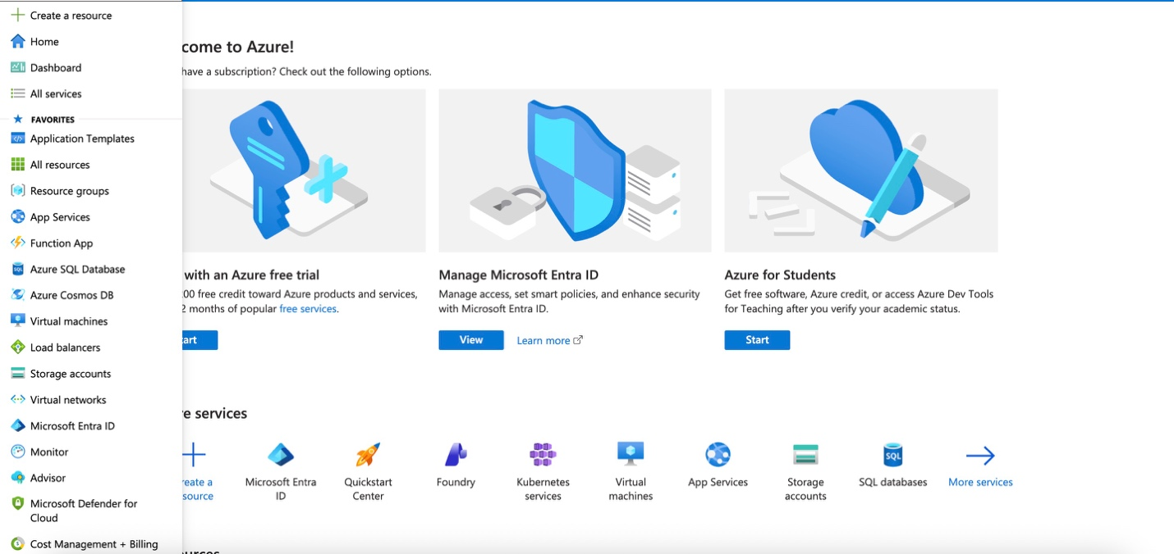

- Select App registrations, then select + Add > App registration
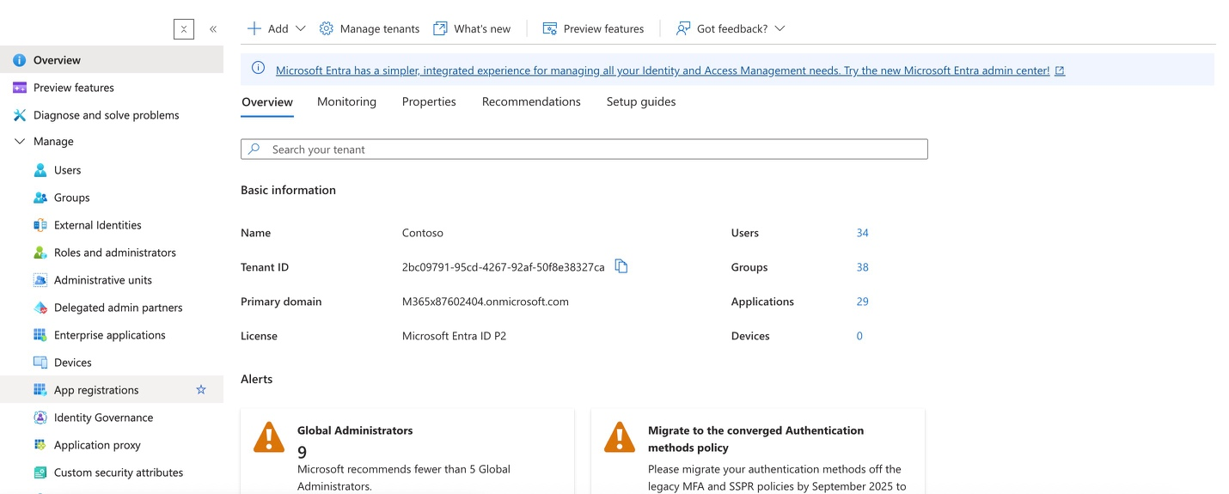
- Complete the form. Then select the Register button. There are 2 sections that you will need to fill in:
  - Name à It is required. Do not leave this space empty.
  - Account types à We recommend choosing the first option (single tenant). It is easier to comply with Microsoft’s Access Policies.
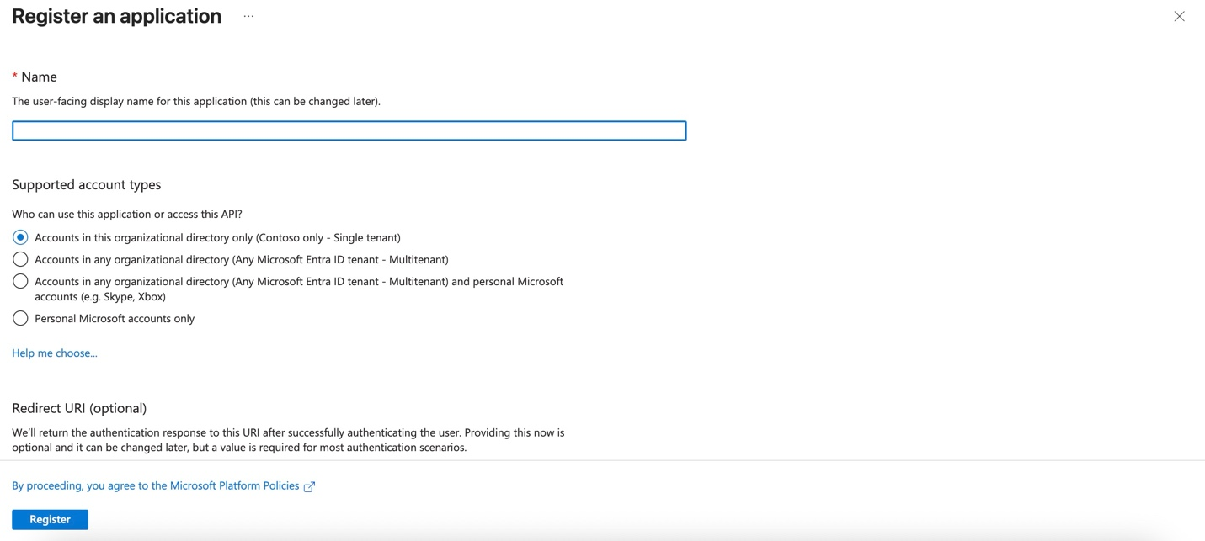

- Once completed, the system will display detail info. Copy the Application (client) ID and paste it to our portal as the Application ID.
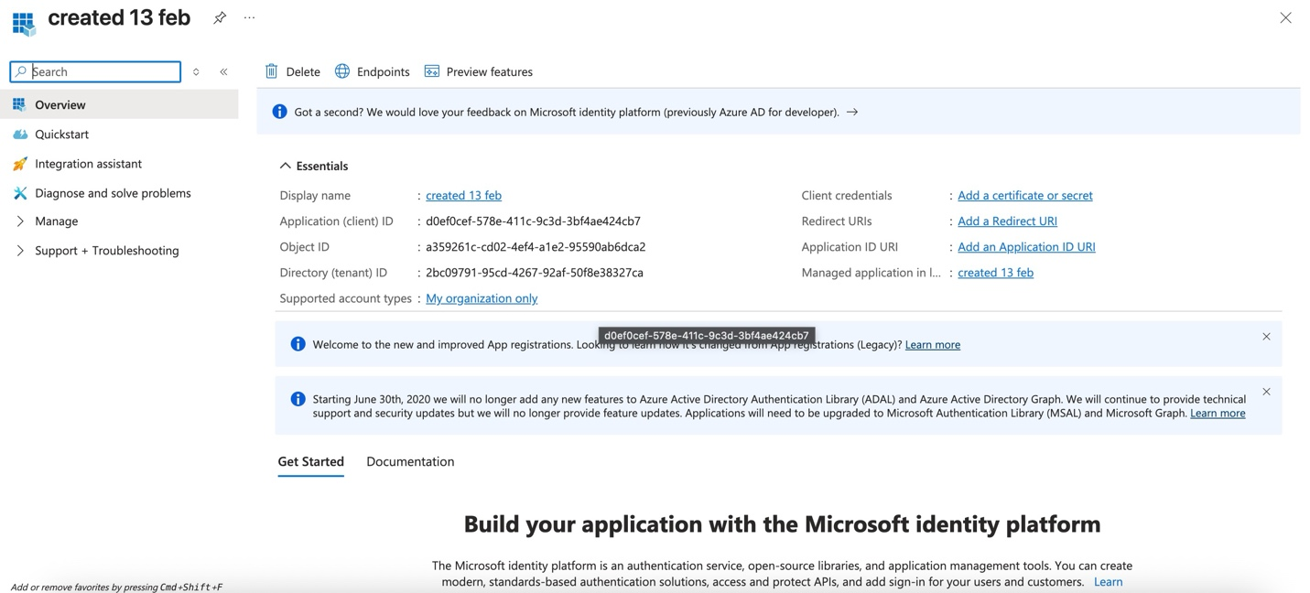

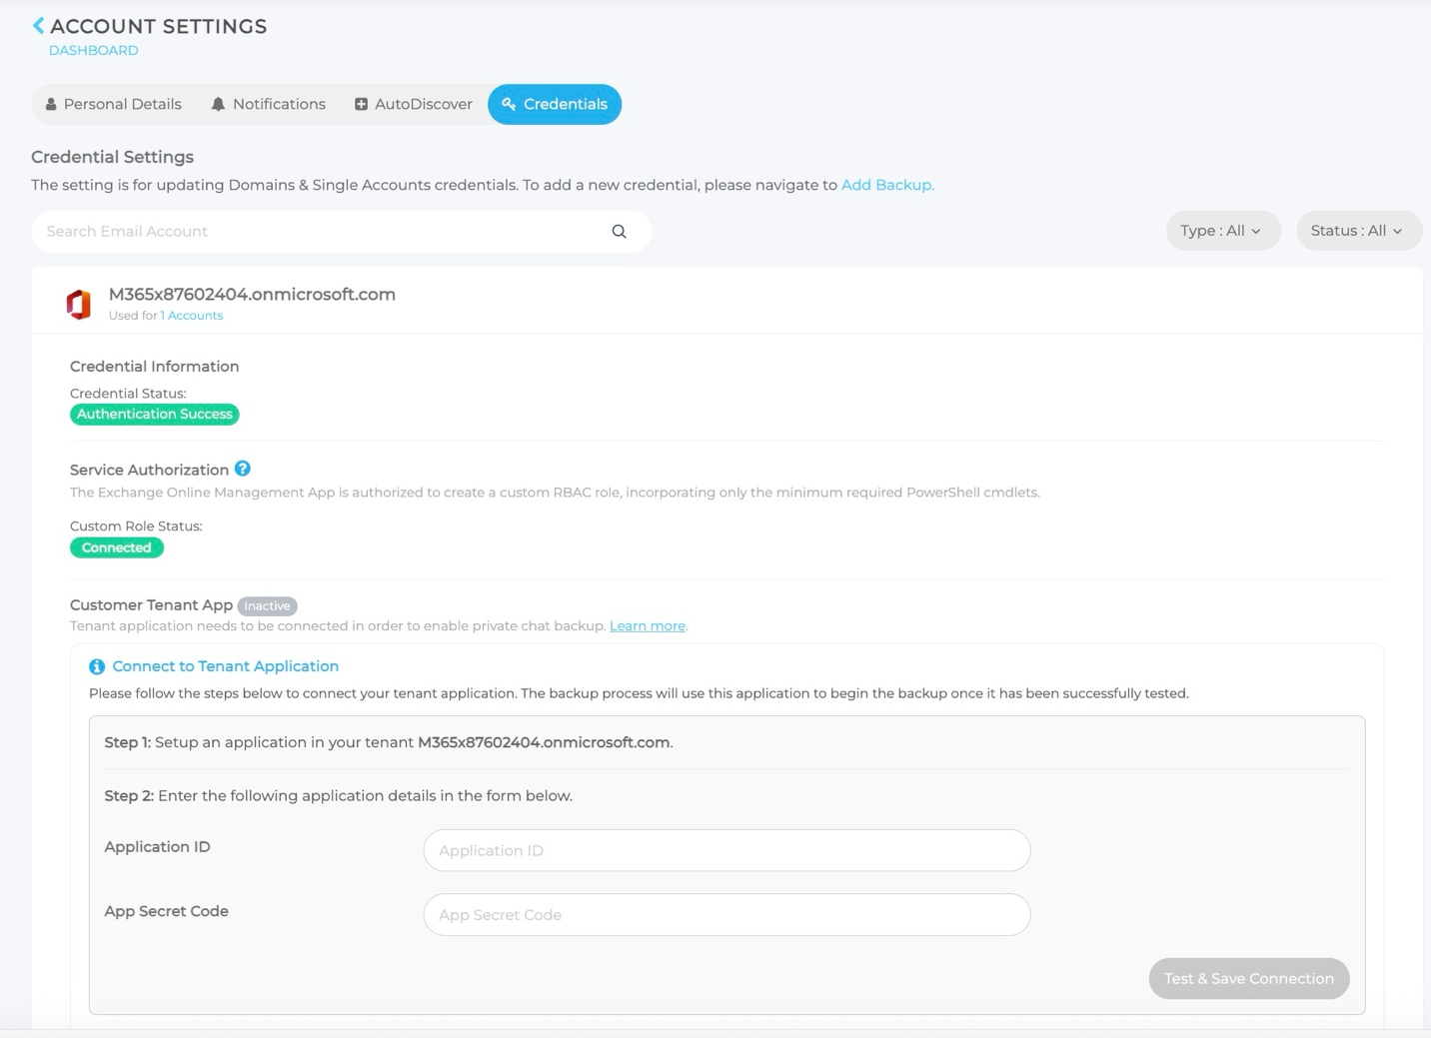

Setup The Registered Application

- Go to https://portal.azure.com and log in using your tenant admin credentials.
- Select Microsoft Entra ID (formerly Azure Active Directory) in the left navigation bar.
- Select App Registrations, and select All applications tab.
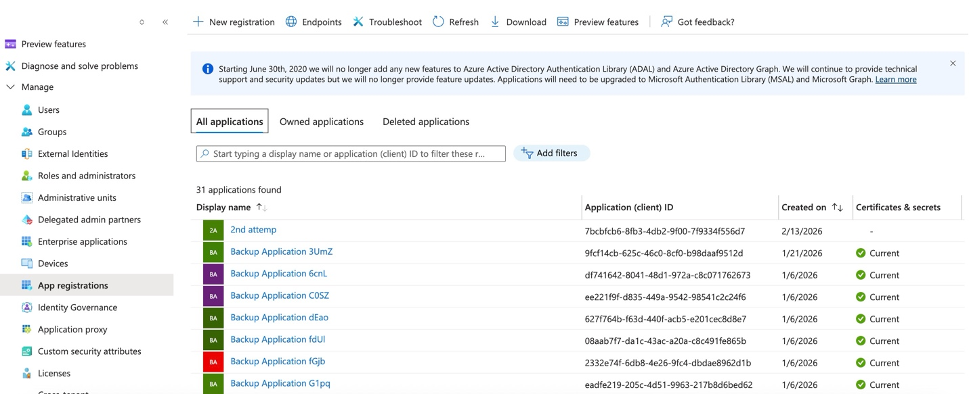
- Select the registered application you’ve created on the above section.
- Expand Manage then select Certificates & secrets. Click + New client secret.
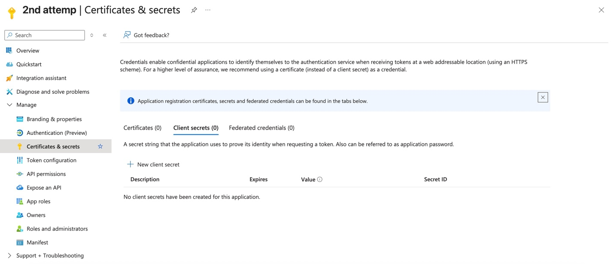

- Input the description, set it to 24 months, and then select Add.
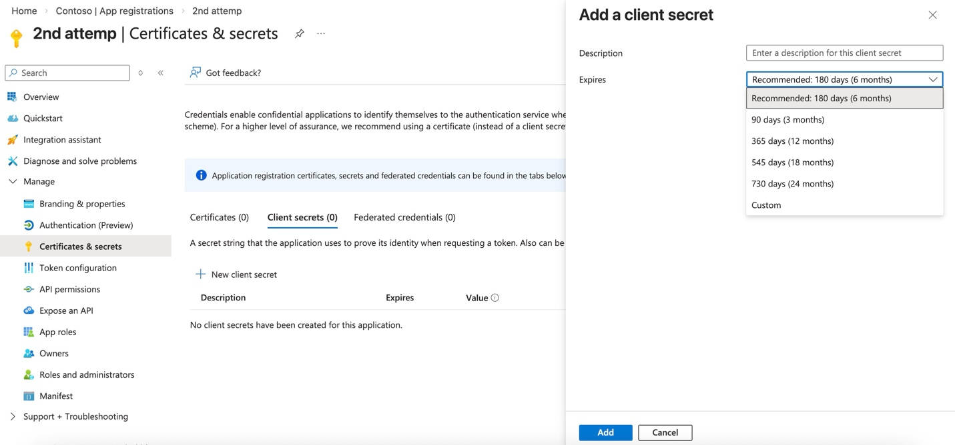
- Once added, immediately copy the value, and paste it to our portal as the application secret code. Please note: Microsoft will only allow you to copy value immediately after creation. Once you leave the page, it cannot be copied, and the full value will be hidden.
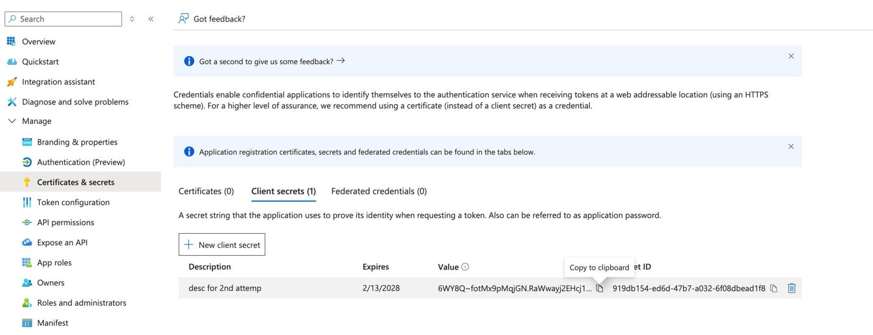

- Select API permissions, then select + Add a permission.
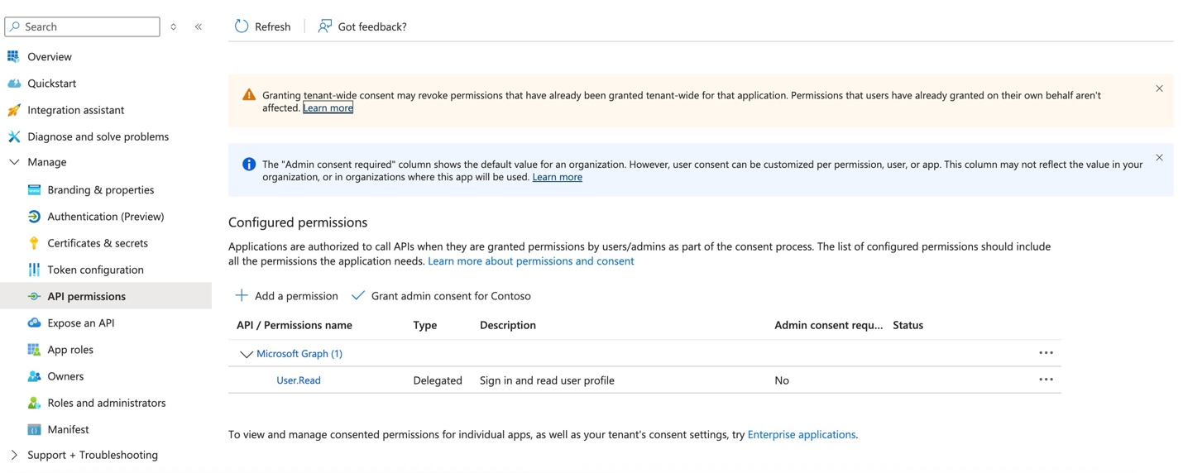

- Select Microsoft Graph.
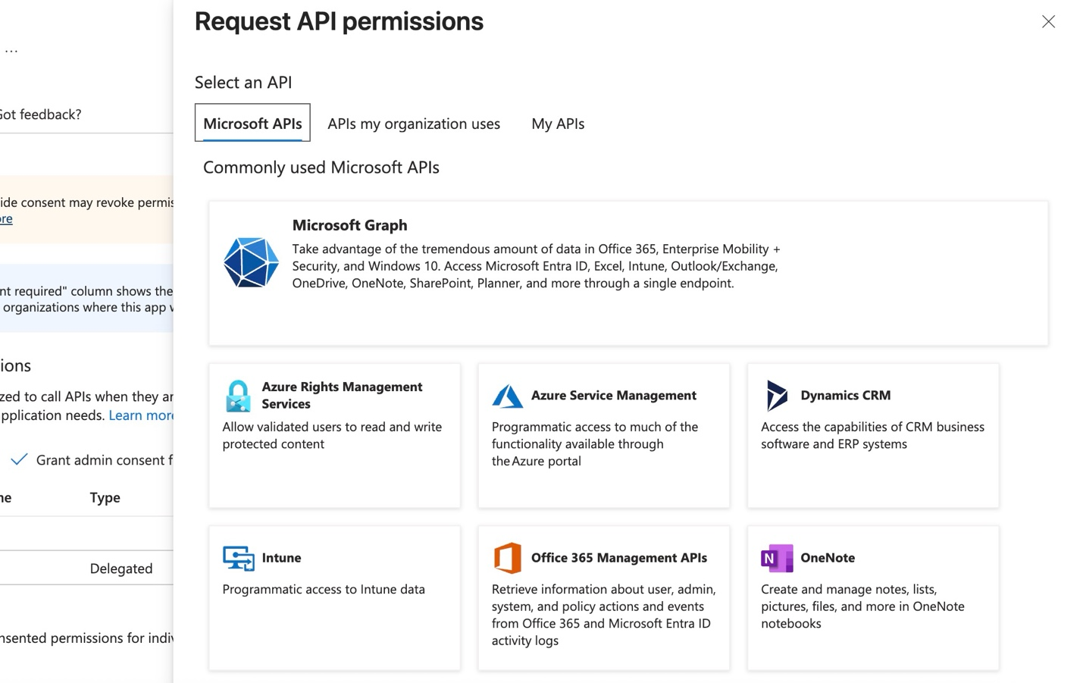
- Select Application permissions.
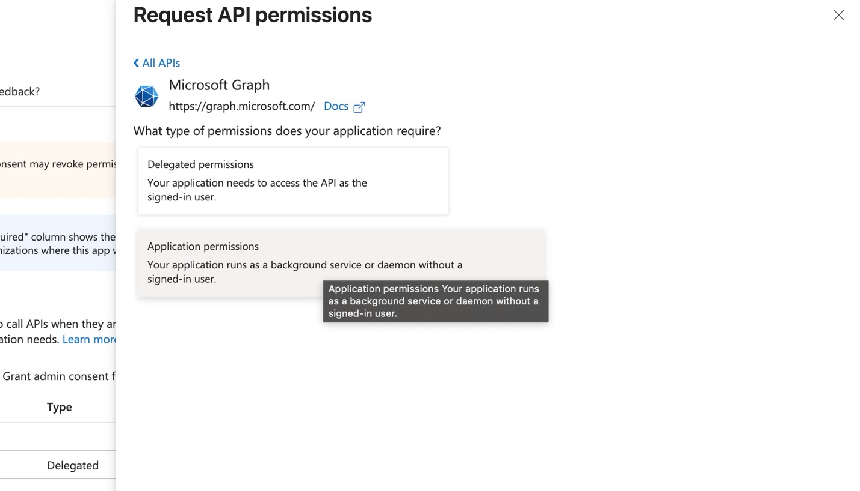
- Input ‘chat’ in search bar, then select Chat.Read.All and Chat.ReadWrite.All, then select Add permissions.
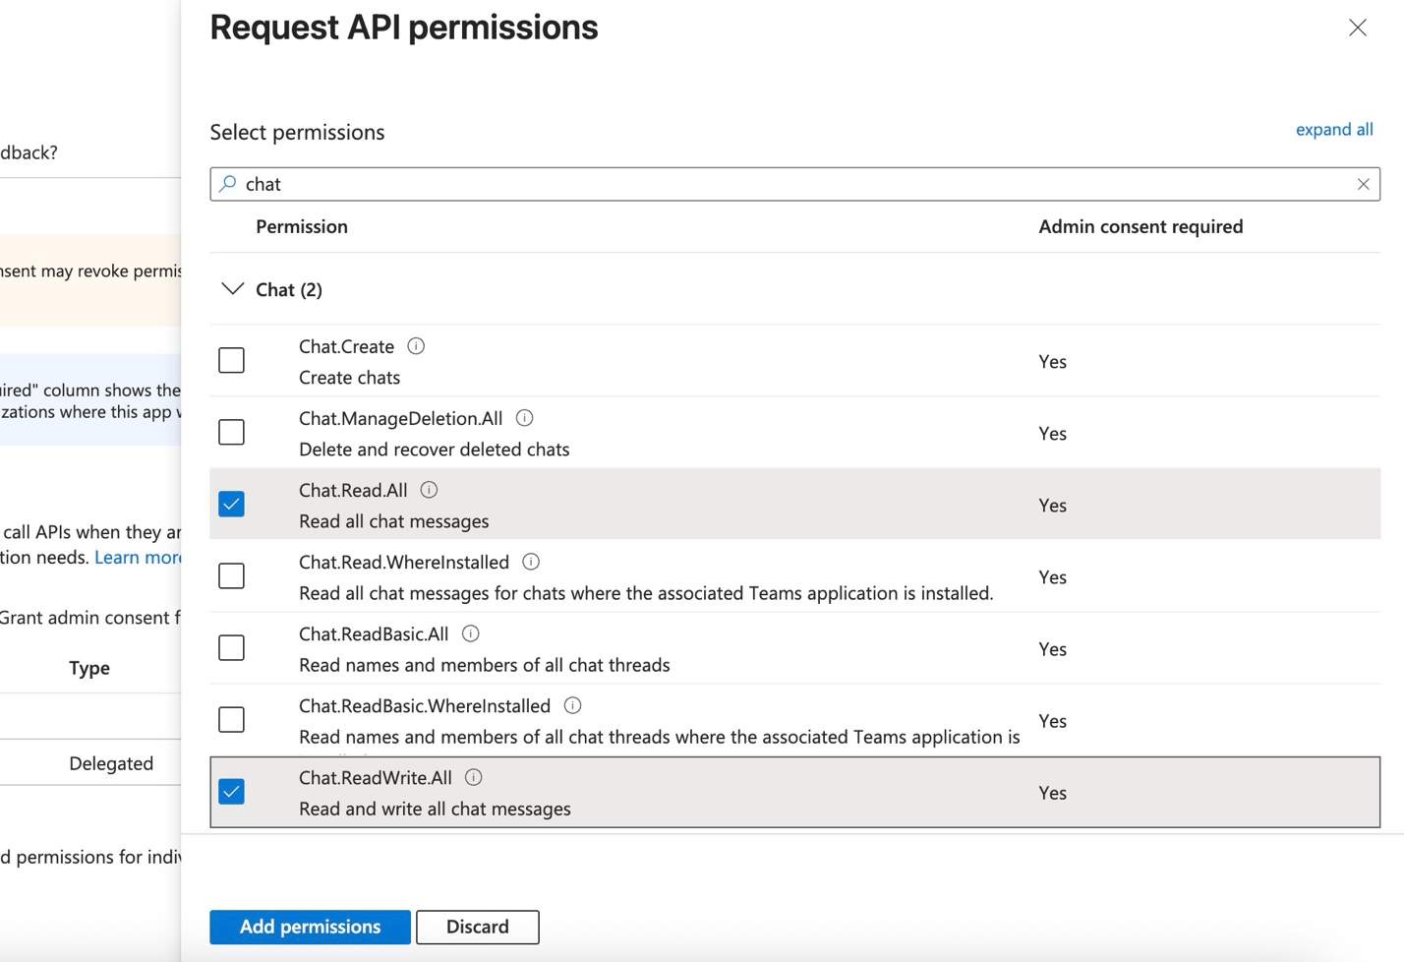
- Do not forget to select Grant admin consent for <domain>.
